**DEEPCYTES REPORT FORMAT**

**General rules: (to be followed on the backend)**

* Name the folder as ‘Report/ToolName_Vertical_YYYYMM_YourName’
* Folder should contain 3 files:
  + Documentation for the work done.
    - The documentation to be named as ‘Doc_ToolName_Vertical_YYYYMM_YourName’
  + .txt file of script for installation
    - The script file to be named as ‘Script_ToolName_Vertical_YYYYMM_YourName’
    - Should include a readme/comments section at the top of the script. (FORMAT TBD)
    - To update the index, click the ‘Update table of contents’ button. 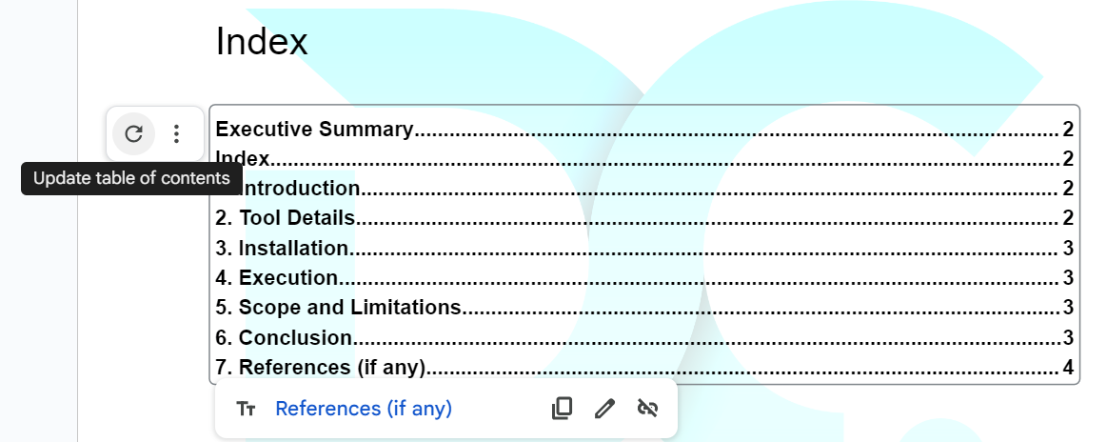
    - Format: Section Headers: Heading 1, Subheaders: Heading 2
  + Demo Video
    - The demo video to be named as ‘Demo_ToolName_Vertical_YYYYMM_YourName’
    - Video format: .mp4
    - Video should include all the use cases as stated in the use cases section in the document.
    - A VO explaining the working must be included.
* Access for this folder should be shared with your Team Manager, [info@deepcytes.io](mailto:info@deepcytes.io) , and any other IDs if mentioned.
* To start editing this document, make a copy and start Page 2 onwards.

**Global Terrorism Database**

**Cyber Intel | GTD | 23rd September 2023**

# Executive Summary

The Global Terrorism Database (GTD) documents more than 200,000 international and domestic terrorist attacks that occurred worldwide since 1970. With details on various dimensions of each attack, the GTD familiarizes analysts, policymakers, scholars, and journalists with patterns of terrorism. The GTD defines terrorist attacks as: The threatened or actual use of illegal force and violence by a non-state actor to attain a political, economic, religious, or social goal through fear, coercion, or intimidation.

# Index

Executive Summary 2

Index 2

1. Introduction 2

2. Tool Details 3

3. Installation 3

4. Execution 3

5. Scope and Limitations 16

6. Conclusion 16

7. References 16

# Introduction

The Global Terrorism Database (GTD) is an open-source database that includes information on terrorist attacks around the world from 1970 through 2023. The GTD includes systematic data on domestic as well as international terrorist incidents that have occurred during this time period and now includes more than 200,000 attacks. The database collects data on a variety of dimensions of each attack, including the date, location, type of attack, perpetrators, victims, and casualties.

The GTD is widely used by analysts, policymakers, scholars, and journalists to understand patterns of terrorism and to develop effective responses to terrorism threats. It is also used to track trends in terrorism over time and to identify areas where terrorism is most prevalent.

**Key features of the GTD:**

* It is the most comprehensive unclassified database on terrorist events in the world.
* It includes data on over 200,000 terrorist attacks from 1970 to 2023.
* It collects data on a variety of dimensions of each attack, including the date, location, type of attack, perpetrators, victims, and casualties.
* It is open-source and freely available to download from the START website.

# Tool Details

Link to Tool: <https://www.start.umd.edu>

Dependencies: NA

Use Cases List:

* Research
* Risk Assessment

Date of installation and run: 23rd September 2023

GUI/CLI/Web: Web

# Installation

**Not Required**

# Execution

**Use Case 1.** Obtaining Terrorist Activities by a particular organisation/group (Eg: ISIS)

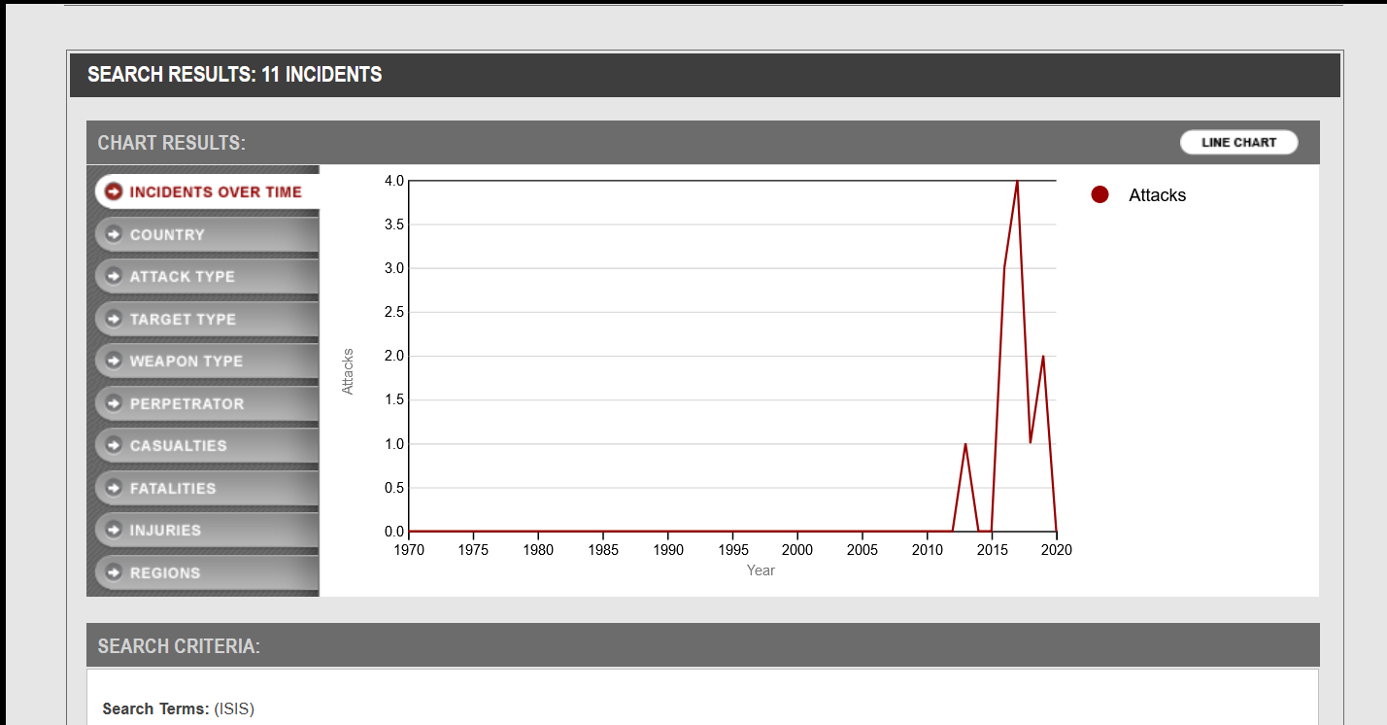

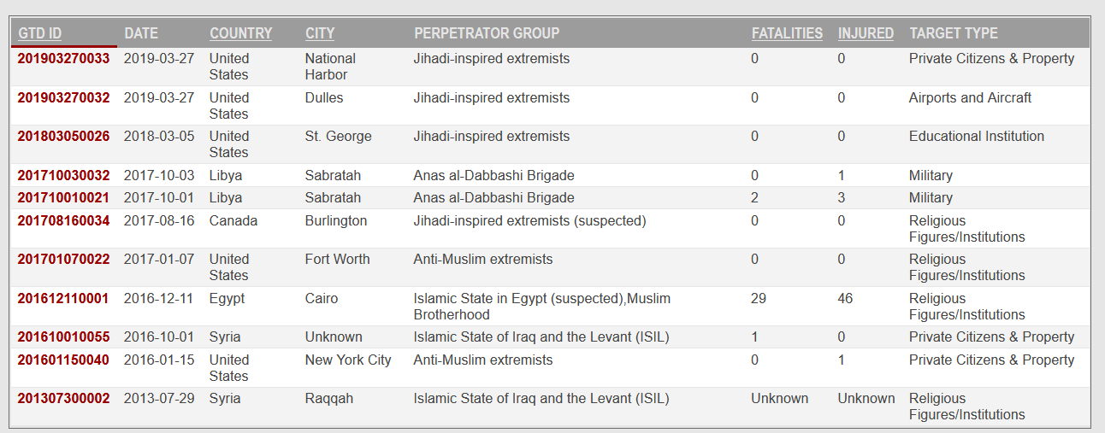

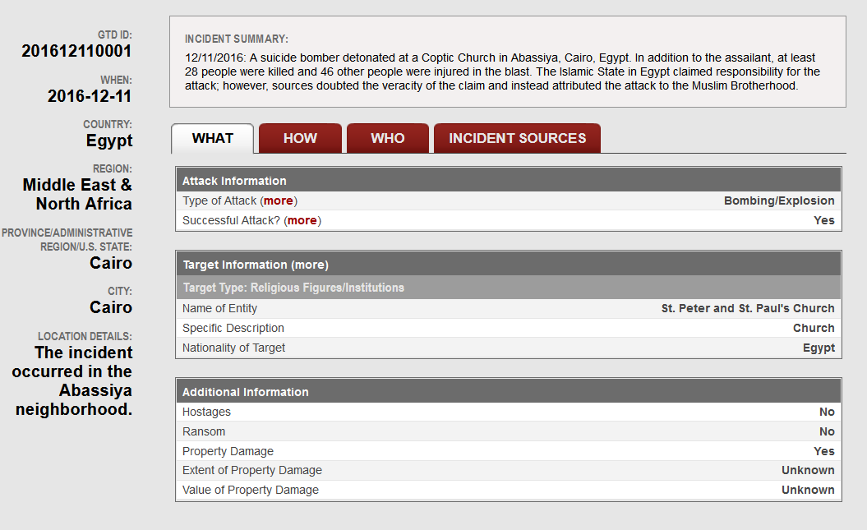

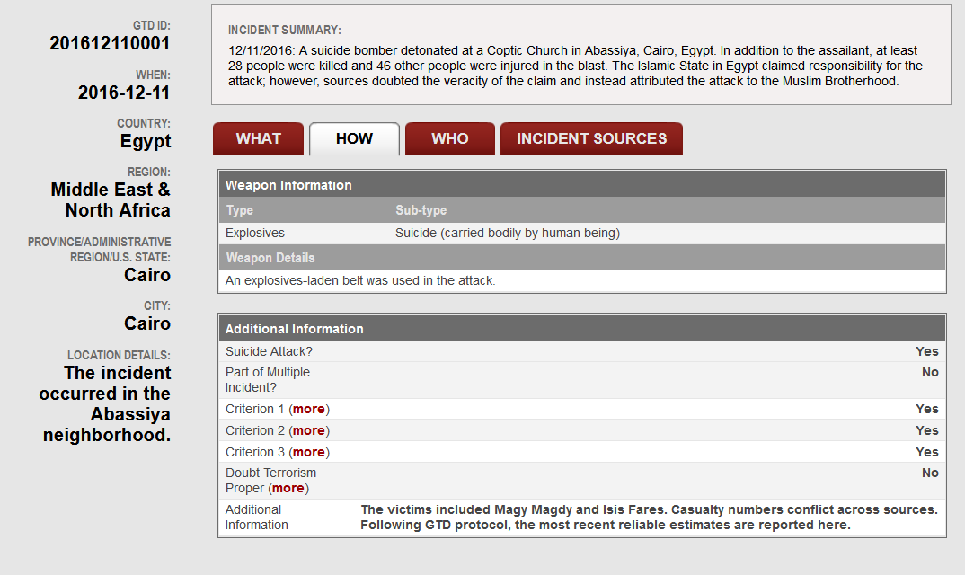

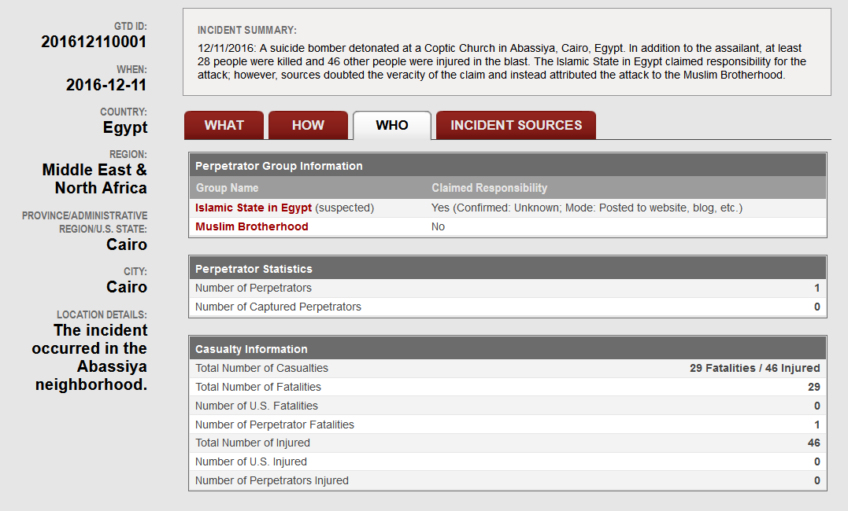

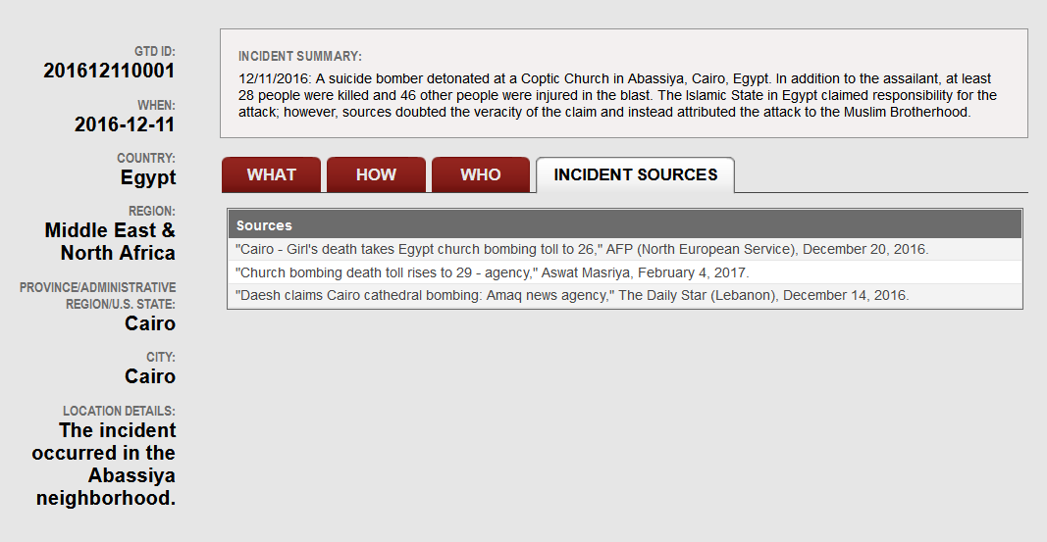

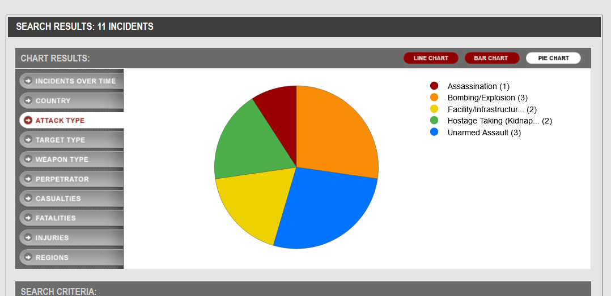

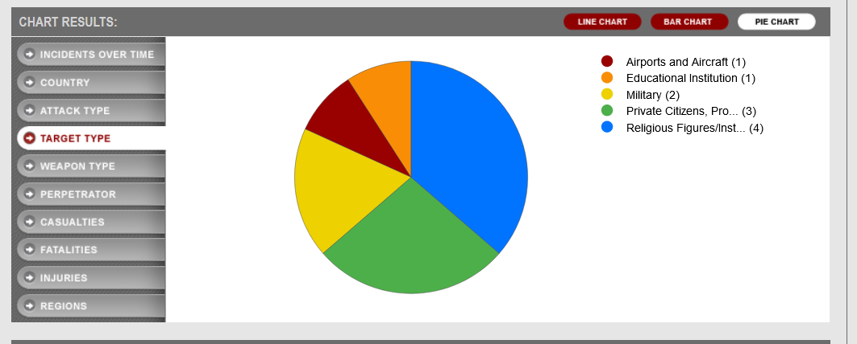

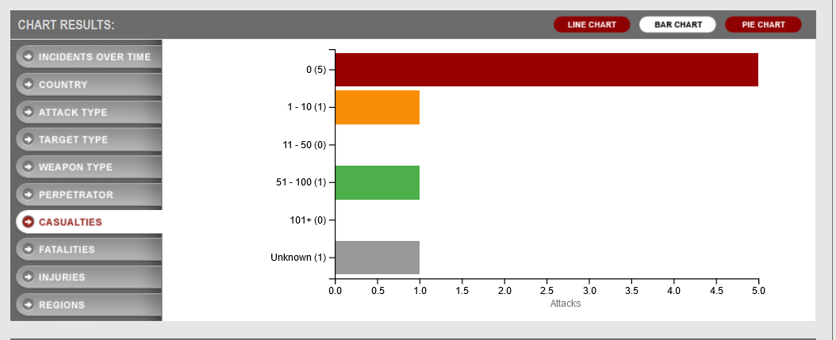

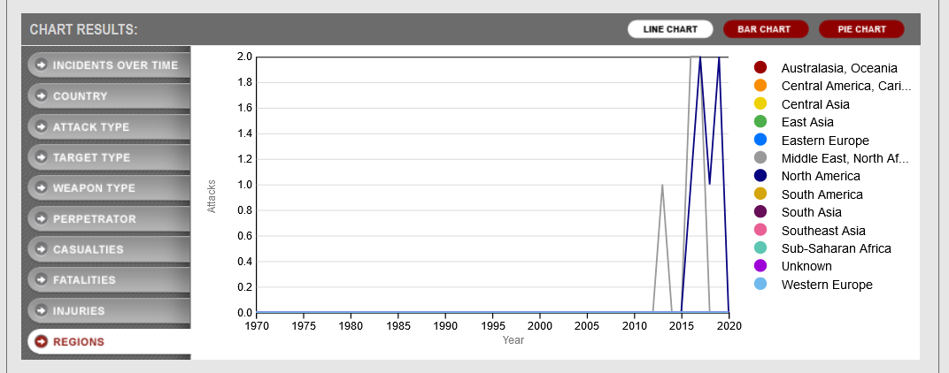

**Use Case 2.** Obtaining information about terrorist activities by country (Eg: Israel)

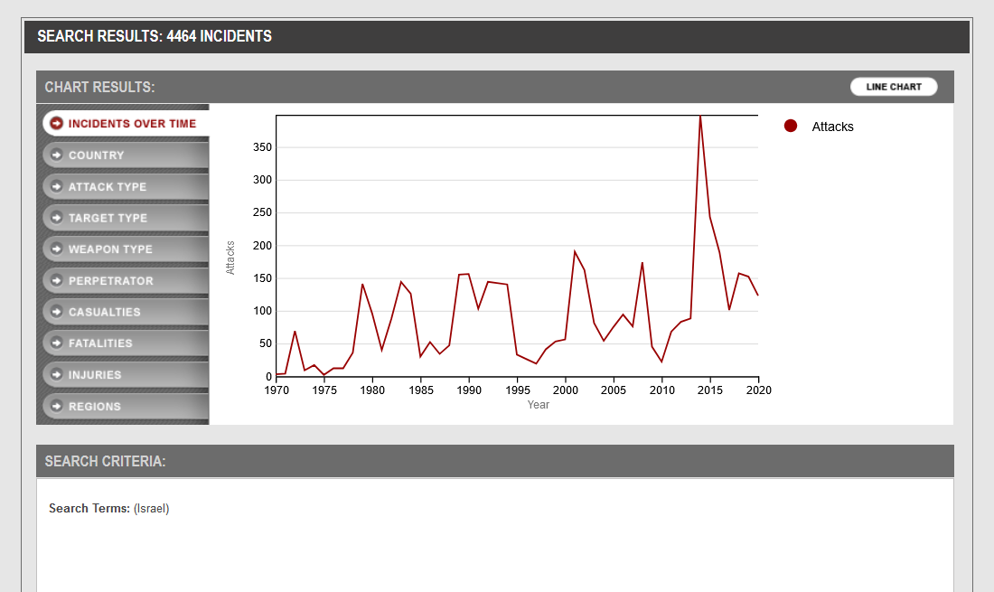

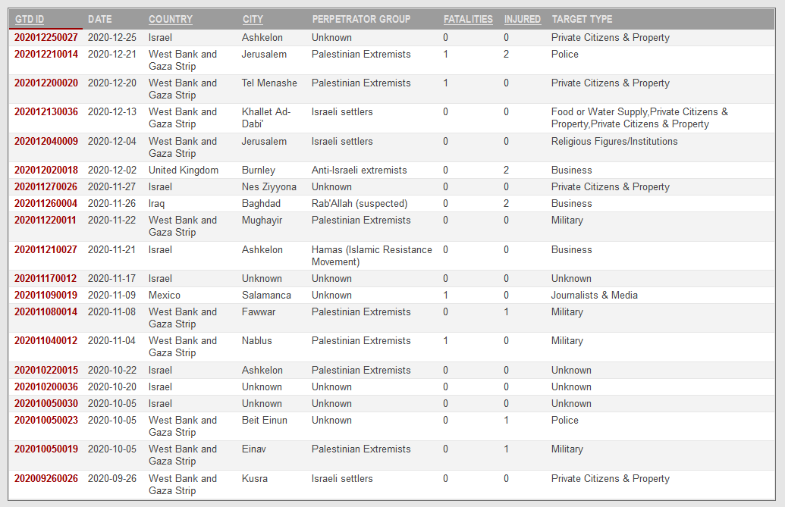

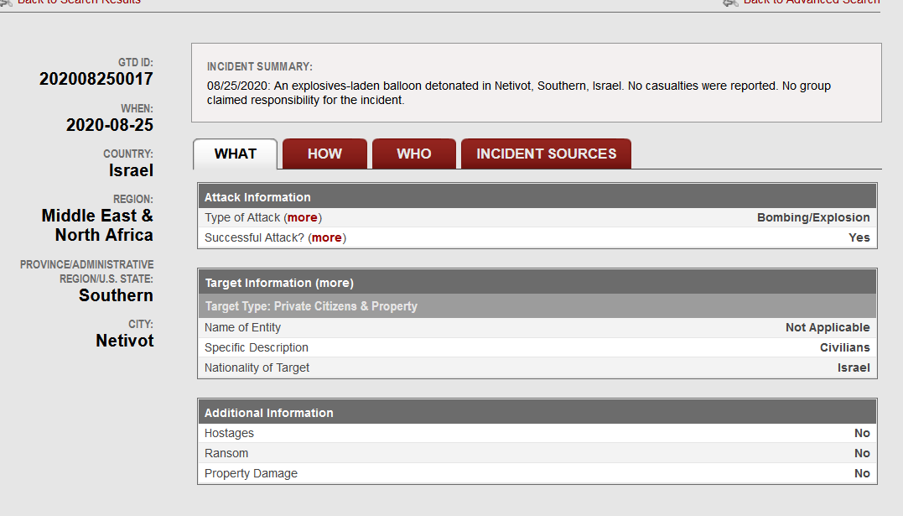

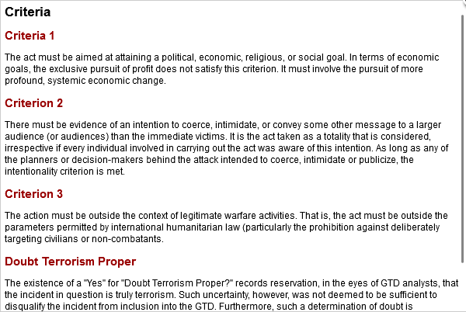

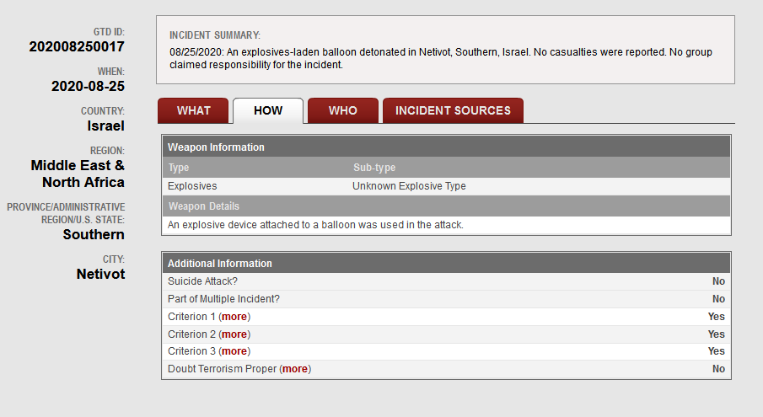

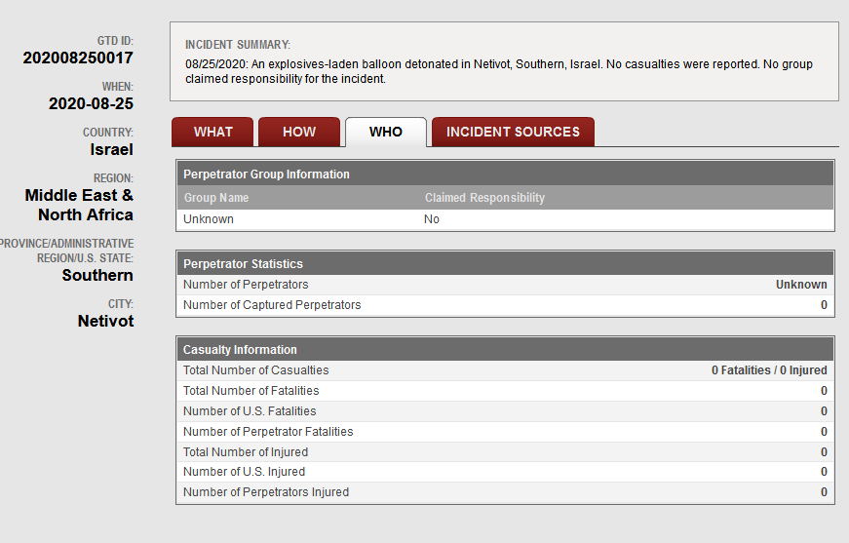

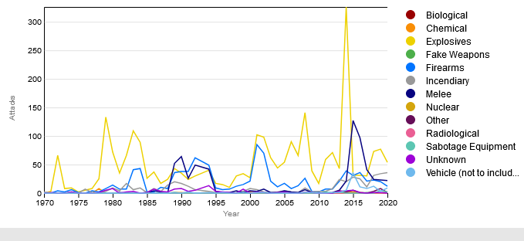

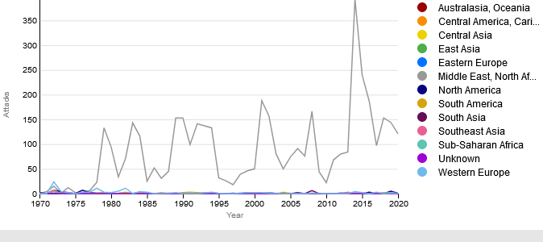

**Use Case 2.** Advanced Search for terrorist activities by different parameters

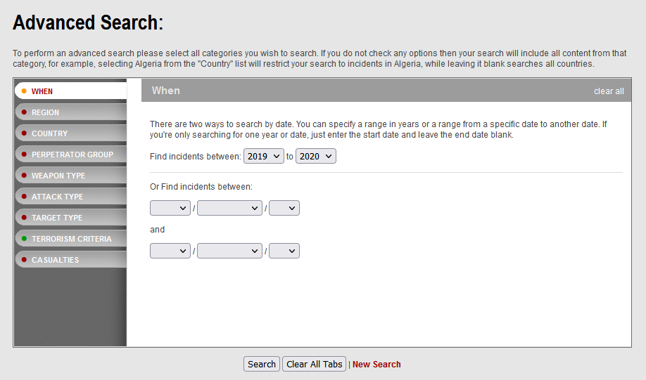

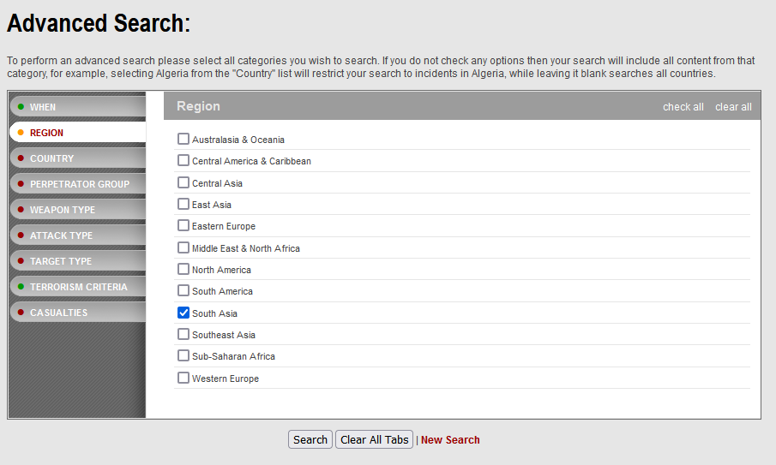

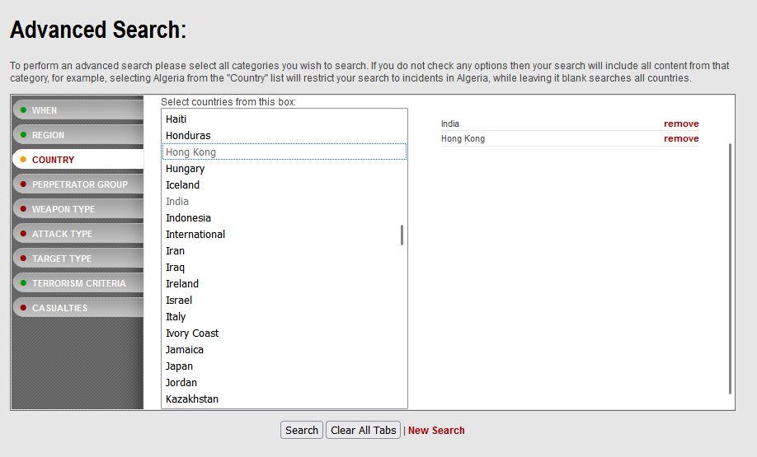

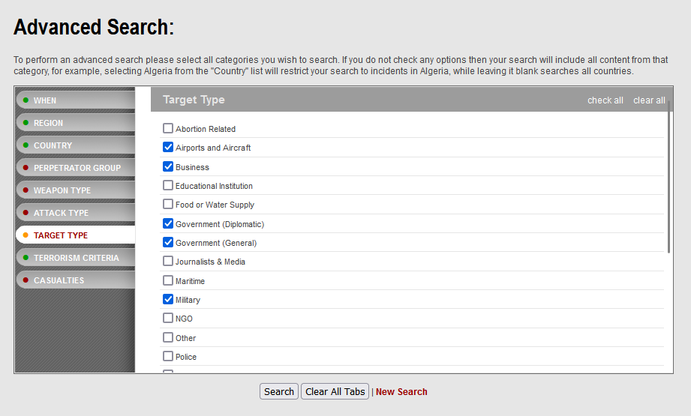

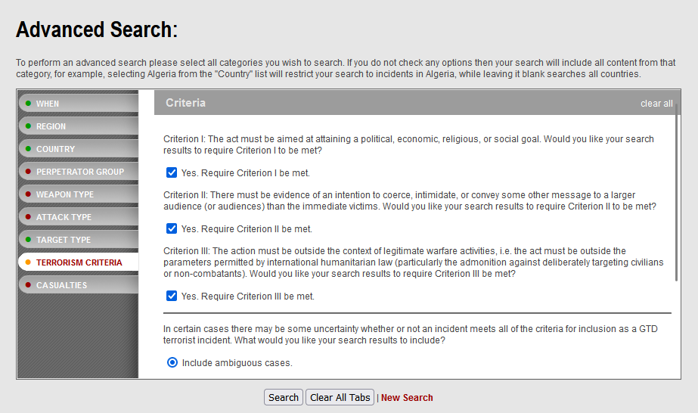

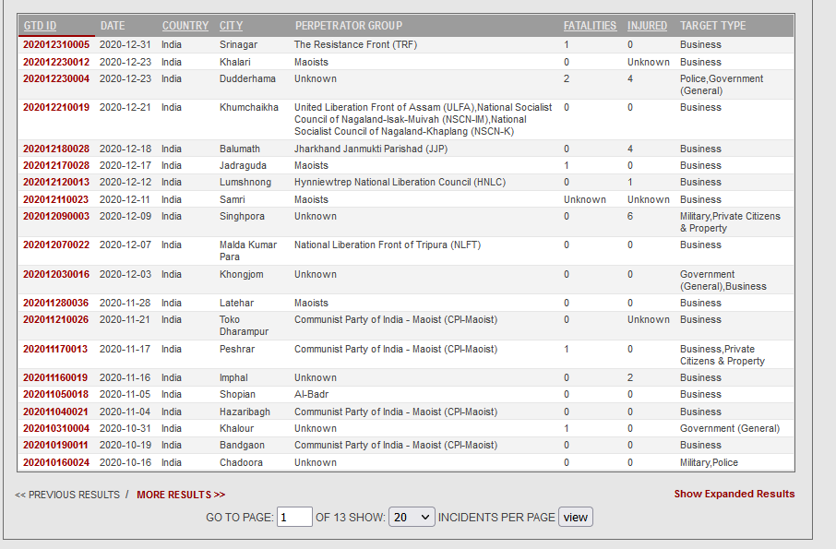

# Scope and Limitations

* One of the main limitations of the GTD is that it is reliant on open-source information. This means that the quality and accuracy of the data can vary depending on the source. Additionally, the database may not include all terrorist attacks that have occurred, especially those that have not been reported in the media.
* Another limitation of the GTD is that it is limited to terrorist attacks. It does not include data on other forms of violence, such as crime or civil war. This can make it difficult to compare the prevalence of terrorism to other forms of violence.

# Conclusion

The GTD is a valuable resource for anyone who wants to learn more about terrorism and its impact on the world

# References

<https://www.start.umd.edu>